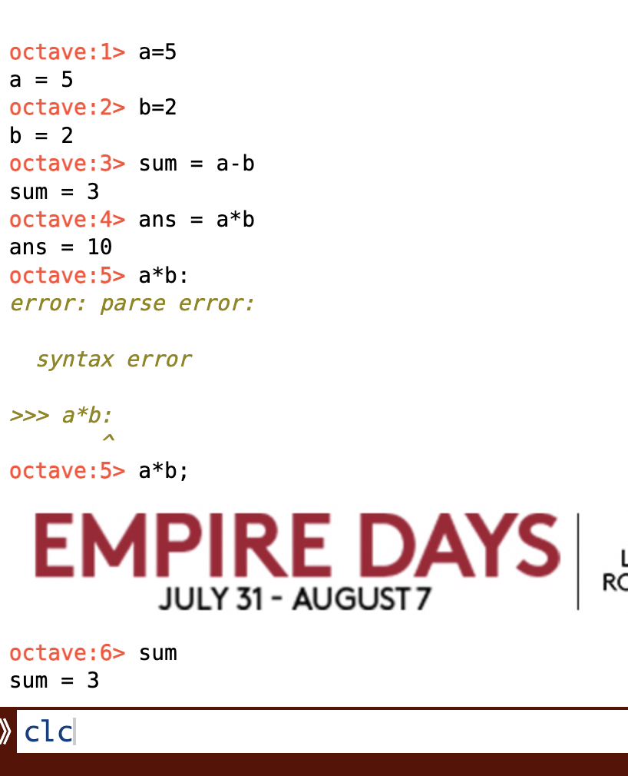

**octave:8>** clear all

**octave:9>** #Array declaration

**octave:9>** a=[1 2 3 4 5 6 7 8 9 10]

a =

1 2 3 4 5 6 7 8 9 10

**octave:10>** a=[1 2 3 4 5 6 7 8 9 10];

**octave:11>** a = 1:10

a =

1 2 3 4 5 6 7 8 9 10

**octave:2>** a = 1:10

a =

1 2 3 4 5 6 7 8 9 10

**octave:3>** b = 1:2:3

b =

1 3

**octave:4>** b = 1:2:10

b =

1 3 5 7 9

**octave:5>** c = 0:.1:1

c =

Columns 1 through 8:

0 0.1000 0.2000 0.3000 0.4000 0.5000 0.6000 0.7000

Columns 9 through 11:

0.8000 0.9000 1.0000

**octave:6>** x = [1 -2 4 5]

x =

1 -2 4 5

**octave:7>** n [0 1 2 3]

*error: parse error:*

*syntax error*

*>>> n [0 1 2 3]*

*^*

**octave:7>** n = [0 1 2 3]

n =

0 1 2 3

**octave:8>** figure(1)

**octave:9>** stem(n,x)

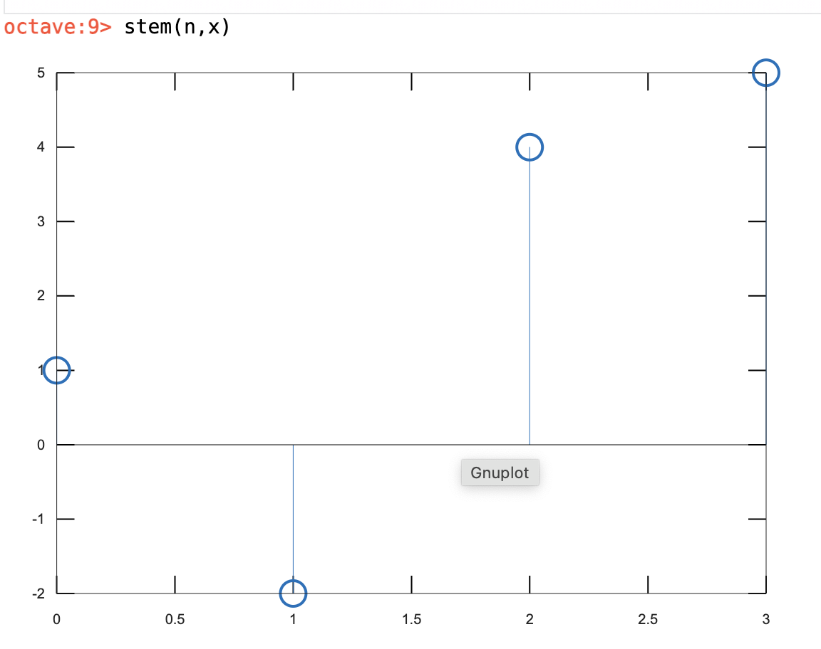

**octave:21>** x=[4:11]

x =

4 5 6 7 8 9 10 11

**octave:22>** n= [3:10]

n =

3 4 5 6 7 8 9 10

**octave:23>** figure(3)

**octave:24>** stem(n,x)

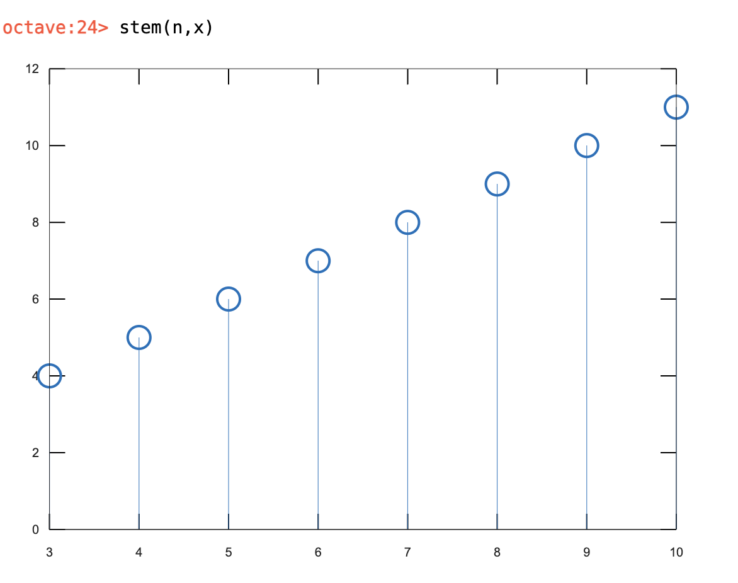

**octave:1>** pi

ans = 3.1416

**octave:2>** a=2

a = 2

**octave:3>** f=3

f = 3

**octave:4>** t= 0:0.1:1

t =

Columns 1 through 8:

0 0.1000 0.2000 0.3000 0.4000 0.5000 0.6000 0.7000

Columns 9 through 11:

0.8000 0.9000 1.0000

xt=a*sin(2*pi*f*t)

xt =

Columns 1 through 8:

0 1.9021 -1.1756 -1.1756 1.9021 0.0000 -1.9021 1.1756

Columns 9 through 11:

1.1756 -1.9021 -0.0000

**octave:9>** figure(2)

**octave:10>** stem(t,xt)

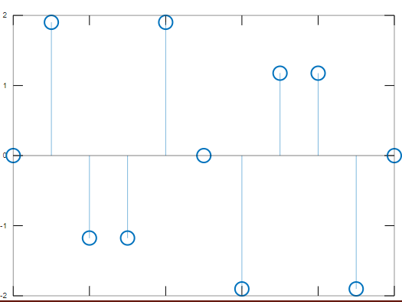

**octave:11>** plot(t,xt)

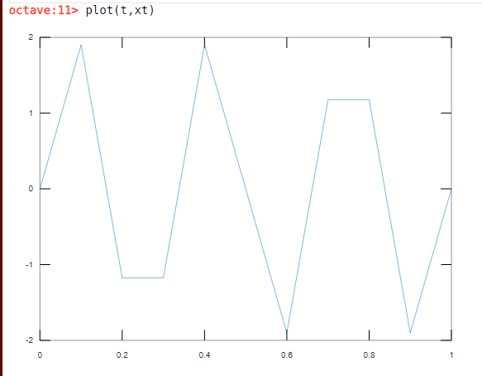

**octave:18>** t1=0:.01:1

t1 =

Columns 1 through 8:

0 0.0100 0.0200 0.0300 0.0400 0.0500 0.0600 0.0700

Columns 9 through 16:

0.0800 0.0900 0.1000 0.1100 0.1200 0.1300 0.1400 0.1500

Columns 17 through 24:

0.1600 0.1700 0.1800 0.1900 0.2000 0.2100 0.2200 0.2300

Columns 25 through 32:

0.2400 0.2500 0.2600 0.2700 0.2800 0.2900 0.3000 0.3100

Columns 33 through 40:

0.3200 0.3300 0.3400 0.3500 0.3600 0.3700 0.3800 0.3900

Columns 41 through 48:

0.4000 0.4100 0.4200 0.4300 0.4400 0.4500 0.4600 0.4700

Columns 49 through 56:

0.4800 0.4900 0.5000 0.5100 0.5200 0.5300 0.5400 0.5500

Columns 57 through 64:

0.5600 0.5700 0.5800 0.5900 0.6000 0.6100 0.6200 0.6300

Columns 65 through 72:

0.6400 0.6500 0.6600 0.6700 0.6800 0.6900 0.7000 0.7100

Columns 73 through 80:

0.7200 0.7300 0.7400 0.7500 0.7600 0.7700 0.7800 0.7900

Columns 81 through 88:

0.8000 0.8100 0.8200 0.8300 0.8400 0.8500 0.8600 0.8700

Columns 89 through 96:

0.8800 0.8900 0.9000 0.9100 0.9200 0.9300 0.9400 0.9500

Columns 97 through 101:

0.9600 0.9700 0.9800 0.9900 1.0000

**octave:19>** xt1=a*sin(2*pi*f*t1)

xt1 =

Columns 1 through 8:

0 0.3748 0.7362 1.0717 1.3691 1.6180 1.8097 1.9372

Columns 9 through 16:

1.9961 1.9842 1.9021 1.7526 1.5410 1.2748 0.9635 0.6180

Columns 17 through 24:

0.2507 -0.1256 -0.4974 -0.8516 -1.1756 -1.4579 -1.6887 -1.8596

Columns 25 through 32:

-1.9646 -2.0000 -1.9646 -1.8596 -1.6887 -1.4579 -1.1756 -0.8516

Columns 33 through 40:

-0.4974 -0.1256 0.2507 0.6180 0.9635 1.2748 1.5410 1.7526

Columns 41 through 48:

1.9021 1.9842 1.9961 1.9372 1.8097 1.6180 1.3691 1.0717

Columns 49 through 56:

0.7362 0.3748 0.0000 -0.3748 -0.7362 -1.0717 -1.3691 -1.6180

Columns 57 through 64:

-1.8097 -1.9372 -1.9961 -1.9842 -1.9021 -1.7526 -1.5410 -1.2748

Columns 65 through 72:

-0.9635 -0.6180 -0.2507 0.1256 0.4974 0.8516 1.1756 1.4579

Columns 73 through 80:

1.6887 1.8596 1.9646 2.0000 1.9646 1.8596 1.6887 1.4579

Columns 81 through 88:

1.1756 0.8516 0.4974 0.1256 -0.2507 -0.6180 -0.9635 -1.2748

Columns 89 through 96:

-1.5410 -1.7526 -1.9021 -1.9842 -1.9961 -1.9372 -1.8097 -1.6180

Columns 97 through 101:

-1.3691 -1.0717 -0.7362 -0.3748 -0.0000

**octave:20>** figure(5)

**octave:21>** plot(t1,xt1)

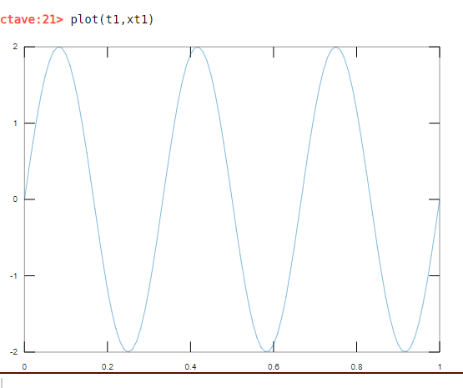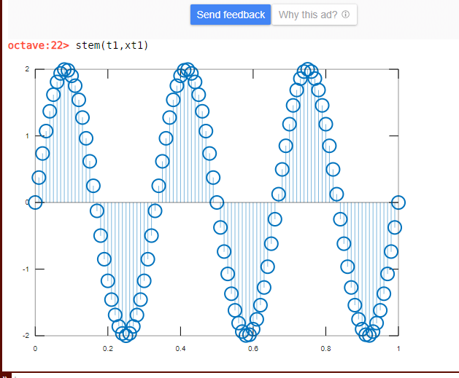

**octave:23>** t2=-1:.05:1

t2 =

Columns 1 through 8:

-1.0000 -0.9500 -0.9000 -0.8500 -0.8000 -0.7500 -0.7000 -0.6500

Columns 9 through 16:

-0.6000 -0.5500 -0.5000 -0.4500 -0.4000 -0.3500 -0.3000 -0.2500

Columns 17 through 24:

-0.2000 -0.1500 -0.1000 -0.0500 0 0.0500 0.1000 0.1500

Columns 25 through 32:

0.2000 0.2500 0.3000 0.3500 0.4000 0.4500 0.5000 0.5500

Columns 33 through 40:

0.6000 0.6500 0.7000 0.7500 0.8000 0.8500 0.9000 0.9500

Column 41:

1.0000

**octave:24>** xt2=a*sin(2*pi*f*t2)

xt2 =

Columns 1 through 8:

0.0000 1.6180 1.9021 0.6180 -1.1756 -2.0000 -1.1756 0.6180

Columns 9 through 16:

1.9021 1.6180 -0.0000 -1.6180 -1.9021 -0.6180 1.1756 2.0000

Columns 17 through 24:

1.1756 -0.6180 -1.9021 -1.6180 0 1.6180 1.9021 0.6180

Columns 25 through 32:

-1.1756 -2.0000 -1.1756 0.6180 1.9021 1.6180 0.0000 -1.6180

Columns 33 through 40:

-1.9021 -0.6180 1.1756 2.0000 1.1756 -0.6180 -1.9021 -1.6180

Column 41:

-0.0000

**octave:25>** stem(t2,xt2)

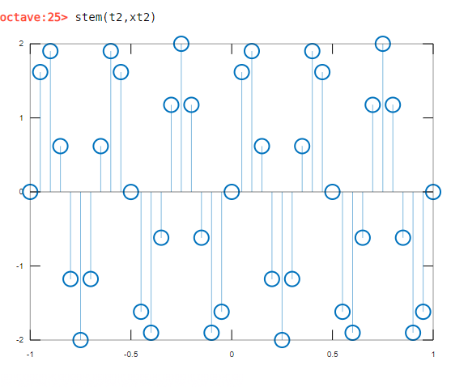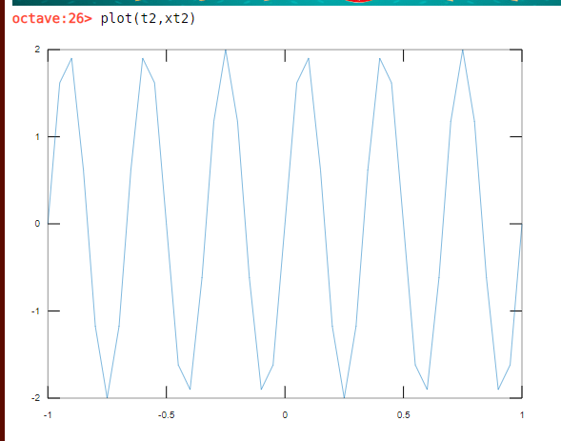

**octave:27>** t3=-1:.05:1

t3 =

Columns 1 through 8:

-1.0000 -0.9500 -0.9000 -0.8500 -0.8000 -0.7500 -0.7000 -0.6500

Columns 9 through 16:

-0.6000 -0.5500 -0.5000 -0.4500 -0.4000 -0.3500 -0.3000 -0.2500

Columns 17 through 24:

-0.2000 -0.1500 -0.1000 -0.0500 0 0.0500 0.1000 0.1500

Columns 25 through 32:

0.2000 0.2500 0.3000 0.3500 0.4000 0.4500 0.5000 0.5500

Columns 33 through 40:

0.6000 0.6500 0.7000 0.7500 0.8000 0.8500 0.9000 0.9500

Column 41:

1.0000

**octave:28>** xt3=a*cos(2*pi*f*t3)

xt3 =

Columns 1 through 6:

2.0000e+00 1.1756e+00 -6.1803e-01 -1.9021e+00 -1.6180e+00 1.1022e-15

Columns 7 through 12:

1.6180e+00 1.9021e+00 6.1803e-01 -1.1756e+00 -2.0000e+00 -1.1756e+00

Columns 13 through 18:

6.1803e-01 1.9021e+00 1.6180e+00 -3.6739e-16 -1.6180e+00 -1.9021e+00

Columns 19 through 24:

-6.1803e-01 1.1756e+00 2.0000e+00 1.1756e+00 -6.1803e-01 -1.9021e+00

Columns 25 through 30:

-1.6180e+00 -3.6739e-16 1.6180e+00 1.9021e+00 6.1803e-01 -1.1756e+00

Columns 31 through 36:

-2.0000e+00 -1.1756e+00 6.1803e-01 1.9021e+00 1.6180e+00 1.1022e-15

Columns 37 through 41:

-1.6180e+00 -1.9021e+00 -6.1803e-01 1.1756e+00 2.0000e+00

**octave:29>** figure(7)

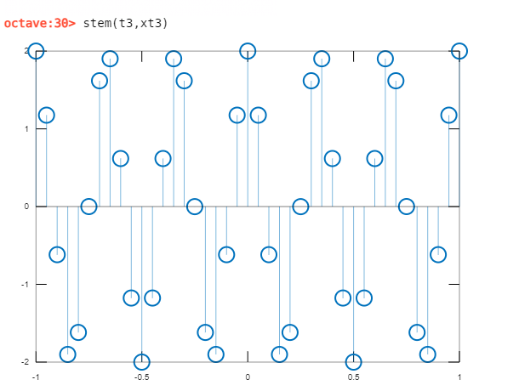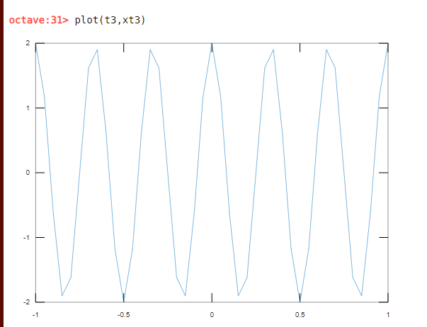



**octave:37>** #defining composite signal

a1=2

a2=3

a3=4

f1=3

f2=10

f3=30

t=0:.01:1

xt1 = a1*sin(2*pi*f1*t)

xt2 = a2*sin(2*pi*f2*t)

xt3 = a3*sin(2*pi*f3*t)

xt=xt1+xt2+xt3

figure(1)

plot(t,xt)

a1 = 2

a2 = 3

a3 = 4

f1 = 3

f2 = 10

f3 = 30

t =

Columns 1 through 8:

0 0.0100 0.0200 0.0300 0.0400 0.0500 0.0600 0.0700

Columns 9 through 16:

0.0800 0.0900 0.1000 0.1100 0.1200 0.1300 0.1400 0.1500

Columns 17 through 24:

0.1600 0.1700 0.1800 0.1900 0.2000 0.2100 0.2200 0.2300

Columns 25 through 32:

0.2400 0.2500 0.2600 0.2700 0.2800 0.2900 0.3000 0.3100

Columns 33 through 40:

0.3200 0.3300 0.3400 0.3500 0.3600 0.3700 0.3800 0.3900

Columns 41 through 48:

0.4000 0.4100 0.4200 0.4300 0.4400 0.4500 0.4600 0.4700

Columns 49 through 56:

0.4800 0.4900 0.5000 0.5100 0.5200 0.5300 0.5400 0.5500

Columns 57 through 64:

0.5600 0.5700 0.5800 0.5900 0.6000 0.6100 0.6200 0.6300

Columns 65 through 72:

0.6400 0.6500 0.6600 0.6700 0.6800 0.6900 0.7000 0.7100

Columns 73 through 80:

0.7200 0.7300 0.7400 0.7500 0.7600 0.7700 0.7800 0.7900

Columns 81 through 88:

0.8000 0.8100 0.8200 0.8300 0.8400 0.8500 0.8600 0.8700

Columns 89 through 96:

0.8800 0.8900 0.9000 0.9100 0.9200 0.9300 0.9400 0.9500

Columns 97 through 101:

0.9600 0.9700 0.9800 0.9900 1.0000

xt1 =

Columns 1 through 8:

0 0.3748 0.7362 1.0717 1.3691 1.6180 1.8097 1.9372

Columns 9 through 16:

1.9961 1.9842 1.9021 1.7526 1.5410 1.2748 0.9635 0.6180

Columns 17 through 24:

0.2507 -0.1256 -0.4974 -0.8516 -1.1756 -1.4579 -1.6887 -1.8596

Columns 25 through 32:

-1.9646 -2.0000 -1.9646 -1.8596 -1.6887 -1.4579 -1.1756 -0.8516

Columns 33 through 40:

-0.4974 -0.1256 0.2507 0.6180 0.9635 1.2748 1.5410 1.7526

Columns 41 through 48:

1.9021 1.9842 1.9961 1.9372 1.8097 1.6180 1.3691 1.0717

Columns 49 through 56:

0.7362 0.3748 0.0000 -0.3748 -0.7362 -1.0717 -1.3691 -1.6180

Columns 57 through 64:

-1.8097 -1.9372 -1.9961 -1.9842 -1.9021 -1.7526 -1.5410 -1.2748

Columns 65 through 72:

-0.9635 -0.6180 -0.2507 0.1256 0.4974 0.8516 1.1756 1.4579

Columns 73 through 80:

1.6887 1.8596 1.9646 2.0000 1.9646 1.8596 1.6887 1.4579

Columns 81 through 88:

1.1756 0.8516 0.4974 0.1256 -0.2507 -0.6180 -0.9635 -1.2748

Columns 89 through 96:

-1.5410 -1.7526 -1.9021 -1.9842 -1.9961 -1.9372 -1.8097 -1.6180

Columns 97 through 101:

-1.3691 -1.0717 -0.7362 -0.3748 -0.0000

xt2 =

Columns 1 through 8:

0 1.7634 2.8532 2.8532 1.7634 0.0000 -1.7634 -2.8532

Columns 9 through 16:

-2.8532 -1.7634 -0.0000 1.7634 2.8532 2.8532 1.7634 0.0000

Columns 17 through 24:

-1.7634 -2.8532 -2.8532 -1.7634 -0.0000 1.7634 2.8532 2.8532

Columns 25 through 32:

1.7634 0.0000 -1.7634 -2.8532 -2.8532 -1.7634 -0.0000 1.7634

Columns 33 through 40:

2.8532 2.8532 1.7634 -0.0000 -1.7634 -2.8532 -2.8532 -1.7634

Columns 41 through 48:

-0.0000 1.7634 2.8532 2.8532 1.7634 0.0000 -1.7634 -2.8532

Columns 49 through 56:

-2.8532 -1.7634 -0.0000 1.7634 2.8532 2.8532 1.7634 -0.0000

Columns 57 through 64:

-1.7634 -2.8532 -2.8532 -1.7634 -0.0000 1.7634 2.8532 2.8532

Columns 65 through 72:

1.7634 -0.0000 -1.7634 -2.8532 -2.8532 -1.7634 0.0000 1.7634

Columns 73 through 80:

2.8532 2.8532 1.7634 0.0000 -1.7634 -2.8532 -2.8532 -1.7634

Columns 81 through 88:

-0.0000 1.7634 2.8532 2.8532 1.7634 0.0000 -1.7634 -2.8532

Columns 89 through 96:

-2.8532 -1.7634 -0.0000 1.7634 2.8532 2.8532 1.7634 -0.0000

Columns 97 through 101:

-1.7634 -2.8532 -2.8532 -1.7634 -0.0000

xt3 =

Columns 1 through 8:

0 3.8042 -2.3511 -2.3511 3.8042 0.0000 -3.8042 2.3511

Columns 9 through 16:

2.3511 -3.8042 -0.0000 3.8042 -2.3511 -2.3511 3.8042 0.0000

Columns 17 through 24:

-3.8042 2.3511 2.3511 -3.8042 -0.0000 3.8042 -2.3511 -2.3511

Columns 25 through 32:

3.8042 0.0000 -3.8042 2.3511 2.3511 -3.8042 -0.0000 3.8042

Columns 33 through 40:

-2.3511 -2.3511 3.8042 -0.0000 -3.8042 2.3511 2.3511 -3.8042

Columns 41 through 48:

-0.0000 3.8042 -2.3511 -2.3511 3.8042 0.0000 -3.8042 2.3511

Columns 49 through 56:

2.3511 -3.8042 -0.0000 3.8042 -2.3511 -2.3511 3.8042 0.0000

Columns 57 through 64:

-3.8042 2.3511 2.3511 -3.8042 -0.0000 3.8042 -2.3511 -2.3511

Columns 65 through 72:

3.8042 0.0000 -3.8042 2.3511 2.3511 -3.8042 0.0000 3.8042

Columns 73 through 80:

-2.3511 -2.3511 3.8042 0.0000 -3.8042 2.3511 2.3511 -3.8042

Columns 81 through 88:

-0.0000 3.8042 -2.3511 -2.3511 3.8042 0.0000 -3.8042 2.3511

Columns 89 through 96:

2.3511 -3.8042 -0.0000 3.8042 -2.3511 -2.3511 3.8042 0.0000

Columns 97 through 101:

-3.8042 2.3511 2.3511 -3.8042 -0.0000

xt =

Columns 1 through 8:

0 5.9423 1.2383 1.5737 6.9367 1.6180 -3.7579 1.4351

Columns 9 through 16:

1.4940 -3.5834 1.9021 7.3202 2.0431 1.7769 6.5311 0.6180

Columns 17 through 24:

-5.3169 -0.6276 -0.9994 -6.4191 -1.1756 4.1096 -1.1866 -1.3575

Columns 25 through 32:

3.6030 -2.0000 -7.5322 -2.3616 -2.1907 -7.0255 -1.1756 4.7160

Columns 33 through 40:

0.0046 0.3764 5.8182 0.6180 -4.6041 0.7728 1.0390 -3.8150

Columns 41 through 48:

1.9021 7.5518 2.4981 2.4392 7.3772 1.6180 -4.1985 0.5696

Columns 49 through 56:

0.2342 -5.1928 -0.0000 5.1928 -0.2342 -0.5696 4.1985 -1.6180

Columns 57 through 64:

-7.3772 -2.4392 -2.4981 -7.5518 -1.9021 3.8150 -1.0390 -0.7728

Columns 65 through 72:

4.6041 -0.6180 -5.8182 -0.3764 -0.0046 -4.7160 1.1756 7.0255

Columns 73 through 80:

2.1907 2.3616 7.5322 2.0000 -3.6030 1.3575 1.1866 -4.1096

Columns 81 through 88:

1.1756 6.4191 0.9994 0.6276 5.3169 -0.6180 -6.5311 -1.7769

Columns 89 through 96:

-2.0431 -7.3202 -1.9021 3.5834 -1.4940 -1.4351 3.7579 -1.6180

Columns 97 through 101:

-6.9367 -1.5737 -1.2383 -5.9423 -0.0000

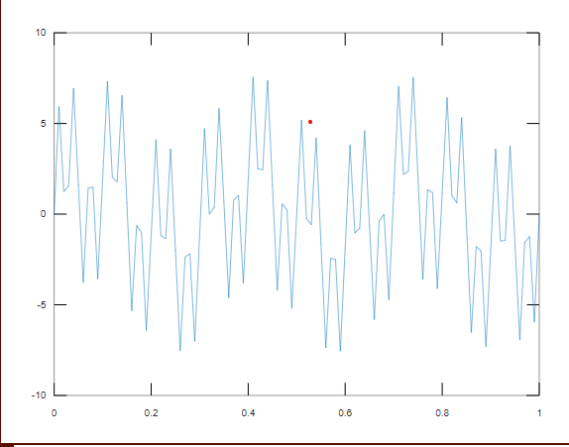

**octave:89>** #Exponent signal

**octave:89>** n=-100:100;

alpha=0.9;

xn=alpha.^n;

figure(4);

stem(n,xn);

